# Power BI Capstone Report for NexusGoods Retail Dataset

**Overview:**

This report details the Power BI dashboard developed to analyze the NexusGoods retail dataset. It addresses eight key business questions using visual analytics on a single report page, formatted for executive-level insights.

1. Top Categories by Total Price

**Question Statement:** Identify and visually represent the top 10 product categories by total sales.

Visualization:  
  
 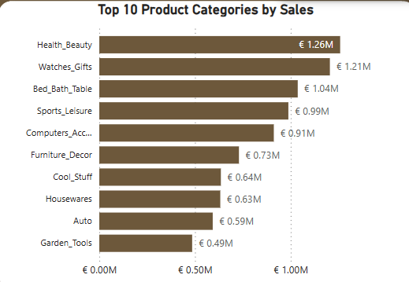

Explanation:  
This chart displays the top 10 product categories based on the sum of item prices. The data was derived by joining order items with products and category translations, summing the total price per category.

2. Delayed Orders Analysis

**Question Statement:** Determine the number of delayed orders in each category. An order is delayed if delivered after the estimated delivery date.

**Visualization:**

Explanation:  
Calculated delayed orders using a new column that checks if delivered_customer_date > estimated_delivery_date and then created a measure Delayed_count. This is then grouped by category to show delayed orders per category.

3. Monthly Comparison of Delayed and On-Time Orders

**Question Statement:** Compare delayed vs on-time orders per month.

**Visualization:**

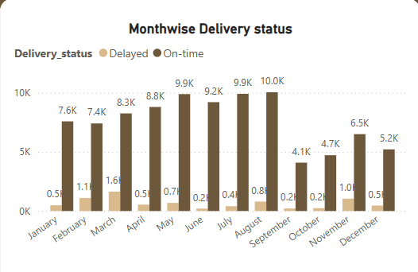

Explanation:  
Created a matrix that groups orders by month and delivery status (delayed or on-time). This graph compares month-wise delayed and on-time deliveries.

4. Payment Method Analysis

**Question Statement:** Analyze the most frequently used payment methods.

Visualization**:**

Explanation**:**  
The chart shows usage counts of each payment method type from the payment dataset. It helps identify preferred customer payment behaviours. Customers prefer credit card payments over other methods.

5. Product Rating Analysis

**Question Statement:** Determine top 10 highest and bottom 10 lowest-rated products.

Visualization:

Explanation:  
Average ratings were calculated by product. A new reviews_table was created with necessary columns to calculate average rating product wise and for overall average rating, which came out to be 4.07. CDs_DVDs_Musicals is the top rated category.

6. State-wise Sales Analysis

**Question Statement:** Identify states with high and low sales.

Visualization:

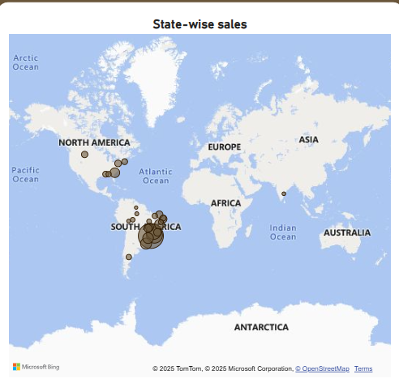

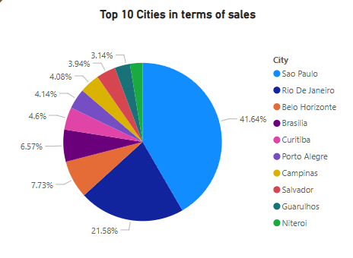

Explanation:  
Sales data joined with customer and geolocation tables to map state-wise totals. Larger bubbles represent higher sales. Sao Paulo has the highest revenue among other states followed by Rio De Janeiro.

7. Seasonal Sales Patterns

**Question Statement:** Investigate seasonal trends (quarterly) in sales.

Visualization:

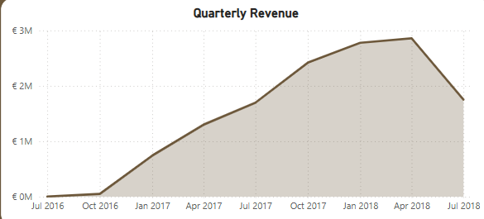 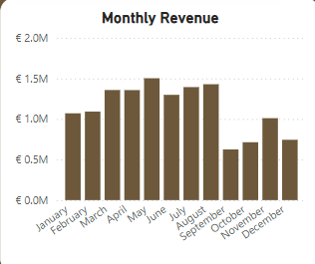

Explanation:  
Sales values are aggregated per quarter. Peaks and dips indicate seasonal demand changes, supporting inventory and marketing planning. Sales peaked in Q2,2018 and then dropped in subsequent quarter (Q3,2018). Monthly Revenue indicates a drop in sales in the month of September, which is the reason for the drop in Q3 sales.

8. Revenue Analysis

**Question Statement:** Determine total revenue over time (Yearly).

Visualization:

Explanation:  
Total revenue was computed from item prices across orders. Trends show annual revenue performance and growth. Revenue has been increasing year-on-year basis.

Summary KPIs on Dashboard:

* Total Revenue: €13.59 million
* On-time Delivery Rate: 91.46%
* Total Customers: 99.44K
* Average Review Score: 4.07
* Total Categories: 71
* Total Products: 32.95K

Notes:

* Currency: All sales and revenue figures are represented in Euros (€).
* All visuals are on a single page for simplicity and real-time decision-making.
* Data connections are maintained for drillthrough and slicers for dynamic interaction.